# Overview

This document provides an overview of the processes used for monthly reconciliation of ActiveNet financial data against Active Accounting (AA) and AMS data in the Reconciliation database.

The analysis procedures are largely executed in SQL Server 2012, using source databases, working tables, and stored procedures, as described below. The process is entire mechanical, and could be further automated. But once the imported data is present, it  takes less than 10 minutes to manually execute the procs for a month and fill  out the spreadsheet, so additional automation isn't cost-effective.

# One-time preparation

You should do the following in advance of your first reconciliation, to ensure you have necessary system access:

## Get access to the reconciliation server

You will need a SQL Server login to the reconciliation server, which you should request through Service-Now. What you should request is the following:

"I need a login for the financial reconciliation SQL Server, WSCASHRECONDB02.active.tan. My login should have the following permissions:

* Full control over the ActiveNet database
* Read access to the other databases on the server
* Access to the linked servers DbAnet01VS, DbAnet10vs and DbPrdCdc"

When you get your login, test is as follows:

* Use SSMS to connect to recon, using the login you received. Note: they will probably just give you TAN domain access for SSMS Windows Authentication, not an actual SQL Server login for SQL Server Authentication. So here’s how to connect to the reconciliation DB server in SSMS on your local box which is logged on to the ACTIVE domain:
* From a CMD window, use “runas.exe” to run SSMS with your TAN domain account, be sure to use the /netonly option:  
  “c:\windows\System32\runas.exe /netonly /user:TAN\<your user> "C:\Program Files (x86)\Microsoft SQL Server\110\Tools\Binn\ManagementStudio\Ssms.exe"
* In the logon prompt, enter DB server name: WSCASHRECONDB02.active.tan. Use “Windows Authentication” and continue. Note: the “user name” field will still say it’s your ACTIVE domain account. Just ignore that, it’s really your TAN account.
* You will now be connected to the WSCASHRECONDB02.active.tan server.
* Open a query window on the Activenet database
* Confirm you can execute the necessary stored procedures by executing this one:

rec_set_month 10,13

You should see a resultset displayed like this:

|  |  |
| --- | --- |
| keyword | value |
| import_beg_date | 9/1/2013 |
| period_beg_date | 10/1/2013 |
| period_end_date | 11/1/2013 |

* Execute the following two SQL statements, to confirm that you have access to the linked servers:

select * from DbAnet01VS.activenetsites.dbo.pools

select * from DbPrdCdc.activenetsites.dbo.pools

Each statement should execute without error, and you should see a resultset.

## Get access to SVN and make sure you have the necessary folder checked out to your local system

* You will need read/write access to the ActiveNet SVN repository. If you don't have that, request it through SVN.
* If you don't have the "unbranched" folder checked out already, checkout the following path:

<https://fndsvn.dev.activenetwork.com/ActiveNet/Unbranched/Reconciliation>

You should get the Reconciliation folder and a few sub-folders.

# “Day 1”: Import ANet data

On “day 1”, the first business day on or after the first of the month, you can start the reconciliation process by setting up the reconciliation spreadsheet, and importing the ActiveNet data from Las Vegas and Toronto data centers into the ActiveNet recon database. (On day 1, the AA and AMS data generally aren’t available yet, so that’s addressed on “day 2”)

ActiveNet data will be ready as soon as the nightly consolidation job is run in the two database data centers. This is generally done by 1:00am Pacific Time each night, so anytime after 1am on the 1st of the month should work (you can confirm success in the process below). At this time you can run the two ActiveNet imports. The rec_import_org_data proc can take up to 40m, whereas the other imports tend to be under 5m, so it's actually good to start them first thing in the morning.

Start by opening WSCASHRECONDB02.active.tan DB server in SSMS and opening a query window on the ActiveNet database.

* **Set month for reconciliation:** Execute the following SQL, with the appropriate month and year filled in:

rec_set_month 5,16

You should see a resultset like this:

|  |  |
| --- | --- |
| keyword | value |
| import_beg_date | 2016-04-29 |
| period_beg_date | 2016-05-01 |
| period_end_date | 2016-06-01 |

* **Import the “rpt” data from ActiveNet:** This is the data from the rpt_rev_v2 table in the ActiveNetSites database in each data center, from a month before the reconciliation period (“import_beg_date” above) to now. This gives summary data for all receipts processed by ANet. It is slightly reformatted and imported into the imported_rpt table, which is used to compare against the AMS and AA data. Execute the following proc:

rec_import_rpt

This will take several minutes to execute, as it’s importing several million records. When it’s done, you should see a resultset like this:

|  |  |  |  |
| --- | --- | --- | --- |
| data_center | First date | Last date | Count |
| Las Vegas | 2016-04-01 00:00:13 | 2016-06-01 07:37:38 | 4995294 |
| Toronto | 2016-04-01 00:00:15 | 2016-06-01 08:05:47 | 691843 |

* **Import org data:** In addition to the rpt_rev_v2 data, the reconciliation process goes to each org database to get some additional information, which can be used to determine the cause of reconciliation mismatches, and whether they are a “defect” or not. This is put into the following tables:

|  |  |
| --- | --- |
| imported_org_info | One record per org of some key configuration information |
| imported_ecp | When there is an ECP failure, ANet generates a payment cancellation, and then a new rpt_rev_v2 record to reverse the charge. However, there is no corresponding record in AMS. This data is used to identify such mismatches and explain them. |
| imported_icverifylog | Not used by procs, but imported as a research aid |

Execute the following proc:

rec_import_org_data

You can start this in another SSMS tab while the rpt import is running. This proc has to connect to each org database, so takes much longer to run, sometimes over an hour. If you want to see how it’s doing, look at the “Messages” tab where you’ll see the output of print statements being executed:

import_beg_date = 4/1/16

*** Create imported_ecp table

*** Create org info table

Jun 1 2016 11:36:01: Import AN from dbanet01vs

Jun 1 2016 11:36:01: Looping starts

Processing DBANET10vs: AARecEd

Processing DBANET01vs: aarecparks

Processing DBANET01vs: Abilene

When this is complete, you should see a resultset like this:

|  |  |
| --- | --- |
| Source | Last_date |
| ECP | 2016-06-01 0:03 |
| Org info | 1411 |

Confirm that you have data for each table. There's no guarantee there will be entries on either table on the last day of the period.

If you see additional result sets which say "Failed to connect to org", like this:

|  |  |  |
| --- | --- | --- |
| Error | currency_code | org |
| Failed to connect to org | CAD | SaultSteMariesandbox |

This means the linked server user didn’t have access to one or more databases on the target server. You’ll need to submit a S/N ticket to resolve. Here is an example:

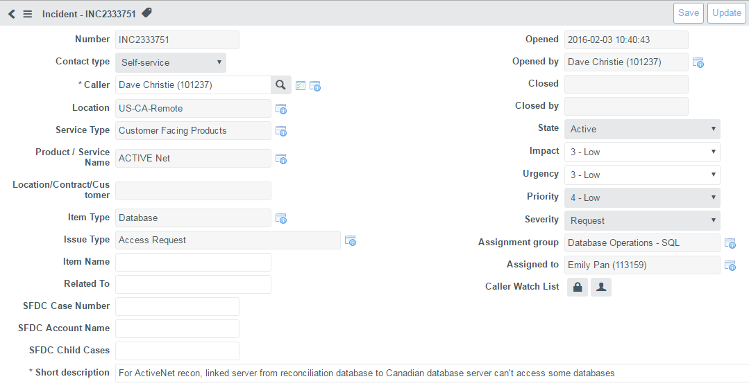

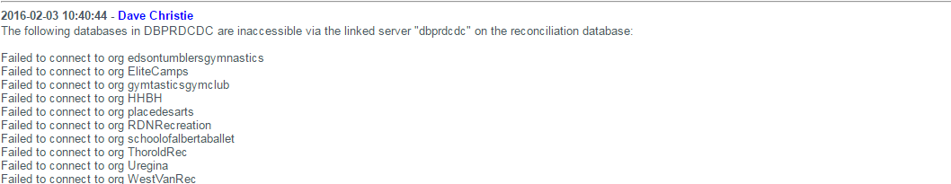

* **Create your reconciliation spreadsheet:**
  + In the reconciliation folder, open the template spreadsheet "Reconciliation - ActiveNet - Template.xlsx"
  + Immediately save it as a month-specific spreadsheet with YYYY-MM in the name, following the existing pattern. E.g., "Reconciliation - ActiveNet - 2016-05.xslx"
  + On the Totals tab, fill in the "Data Extraction Period" and the "Date Processed" on the Totals tab:

|  |  |
| --- | --- |
| **Totals** |  |
|  |  |
| **Data Extraction Period** | 2016-05 |
| **Date processed** | 2016-06-01 |

* + Save the spreadsheet again.

In general, you’ll see the spreadsheet template is setup with yellow regions anywhere you paste in or enter text; other regions may have formulas and should be left alone.

# “Day 2”: Import AMS and AA data

You should wait until you receive an email saying the AMS and AN data are ready, which is generally on the second day of the month, or the next business day. Another way of knowing the data is finalized is when you receive an email with a subject like “like “ActiveNet cover page for your triad spreadsheet - monthly cash reconciliation”. You can run the AA and AMS imports earlier, and sometimes the data is there; but sometimes it appears to be ready, but the data wasn’t complete, and it causes experience reconciliation mismatches, and confusion while you’re researching them. So wait.

* **Import AMS data:** Execute the following proc, which will import the AMS data for the reconciliation period,

rec_import_ams

This will take several minutes, and display a result set like this:

|  |  |  |
| --- | --- | --- |
| (No column name) | Min date | Max date |
| AMS date range | 2016-04-01 00:00:14 | 2016-06-02 23:59:50 |

Confirm that the max transaction date is at least the end of the day on the 1st of the month. We want to allow time for deferred capture transactions (12 hours) + max Eastern timezone (7h), to be able to determine when an AMS record is missing, versus simply delayed by a timezone difference or deferred capture.

* **Import AA data:** Execute the following proc, which will import the AA data for the reconciliation period. Note that you can execute it in a different SSMS window in parallel with the AMS import:

rec_import_aa

This will take several minutes, and display a result set like this:

|  |  |  |
| --- | --- | --- |
| (No column name) | Min date | Max date |
| AA date range | 2016-04-01 00:00:13 | 2016-05-31 23:59:51 |

Confirm that the max transaction date is just before midnight on the end of the reconciliation period.

# Transfer all raw data into spreadsheet

* **Generate totals and copy into spreadsheet:** Execute the following proc:

rec_totals

It will generate four result sets, as follows:

|  |  |  |  |  |  |  |
| --- | --- | --- | --- | --- | --- | --- |
|  | period_beg_date | period_end_date | inc_red | currency | rev_total | cash_total |
| For AA | 2005-01-16 | 2006-01-16 |  | USD | $4,259,257.46 | $91,426,983.22 |
| For AA | 2005-01-16 | 2006-01-16 |  | CAD | $ 464,518.35 | $ 8,236,044.91 |

|  |  |  |  |  |  |  |
| --- | --- | --- | --- | --- | --- | --- |
|  | period_beg_date | period_end_date | inc_red | currency | rev_total | cash_total |
| For AMS | 2005-01-16 | 2006-01-16 | I | USD | $4,263,853.40 | $105,421,133.63 |
| For AMS | 2005-01-16 | 2006-01-16 | I | CAD | $ 464,683.51 | $ 11,686,228.96 |
| For AMS | 2005-01-16 | 2006-01-16 | I | AUD | - | $ - |
| For AMS | 2005-01-16 | 2006-01-16 | R | USD | $(4,595.94) | $ (3,305,542.88) |
| For AMS | 2005-01-16 | 2006-01-16 | R | CAD | $(165.16) | $ (517,692.33) |

|  |  |  |  |  |  |  |
| --- | --- | --- | --- | --- | --- | --- |
|  | period_beg_date | period_end_date | inc_red | currency | rev_total | cash_total |
| AA Totals | 2005-01-16 | 2006-01-16 |  | USD | $4,258,042.01 | $91,169,798.64 |
| AA Totals | 2005-01-16 | 2006-01-16 |  | CAD | $ 464,519.58 | $ 8,236,044.91 |
| AA Totals | 2005-01-16 | 2006-01-16 |  | AUD | $ - | $ 0.00 |

|  |  |  |  |  |  |
| --- | --- | --- | --- | --- | --- |
|  | period_beg_date | period_end_date | inc_red | currency | cash_total |
| AMS Totals | 2005-01-16 | 2006-01-16 | I | USD | $103,895,198.30 |
| AMS Totals | 2005-01-16 | 2006-01-16 | I | CAD | $ 11,785,550.16 |
| AMS Totals | 2005-01-16 | 2006-01-16 | R | USD | $ (3,256,863.76) |
| AMS Totals | 2005-01-16 | 2006-01-16 | R | CAD | $ (514,424.39) |

Paste the highlighted section of each result set into the corresponding section of the Totals tab, making sure the “Inc_Red” matches “Increases” and “Reductions” on those sections which specify that, and that the Currency matches. You’ll see not all sections currently have any AUD (Australian dollar) data.

|  |  |  |  |  |
| --- | --- | --- | --- | --- |
| **Transaction totals sent to AA** | | |  |  |
| **Type** | **Currency** | | **Revenue** | **Cash** |
|  | USD | | $ 4,259,257.46 | $ 91,426,983.22 |
|  | CAD | | $ 464,518.35 | $ 8,236,044.91 |
|  | AUD | |  |  |
|  |  | |  |  |
| **Transaction totals processed through AMS** | | | |  |
| **Type** | **Currency** | **Revenue** | | **Cash** |
| Increases | USD | $ 4,263,853.40 | | $ 105,421,133.63 |
|  | CAD | $ 464,683.51 | | $ 11,686,228.96 |
|  | AUD | $ - | | $ - |
| Reductions | USD | $ (4,595.94) | | $ (3,305,542.88) |
|  | CAD | $ (165.16) | | $ (517,692.33) |
|  | AUD |  | |  |
|  |  |  | |  |
| **AA Totals** |  |  | |  |
| **Type** | **Currency** | **Revenue** | | **Cash** |
|  | USD | $ 4,258,042.01 | | $ 91,169,798.64 |
|  | CAD | $ 464,519.58 | | $ 8,236,044.91 |
|  | AUD | $ - | | $ - |
|  |  |  | |  |
|  |  |  | |  |
| **AMS totals** |  |  | |  |
| **Type** | **Currency** | **Cash** | |  |
| Increases | USD | $ 103,895,198.30 | |  |
|  | CAD | $ 11,785,550.16 | |  |
|  | AUD |  | |  |
| Reductions | USD | $ (3,256,863.76) | |  |
|  | CAD | $ (514,424.39) | |  |
|  | AUD |  | |  |

* **Generate the AMS exceptions and paste into the AMS Exceptions tab:** Execute the following proc.

rec_exceptions_ams

This will generate a large table (currently over 100K rows) listing every single receipt for which the AN data and AMS don’t match. Most of these are because of timezone differences between the org’s time and AMS time (Pacific time) for transactions at the beginning or end of the month, but those at the top marked as “defects” will need to be “explained” later.

|  |  |  |  |  |  |  |  |  |  |  |  |  |  |
| --- | --- | --- | --- | --- | --- | --- | --- | --- | --- | --- | --- | --- | --- |
| defect | group_key | adj_cash_amt | org | receipt_number | description | src_date | src_cash_amt | dst_date | dst_cash_amt | transaction_id | merchant | explanation | extra_explanation |
| 1 | I-CAD | $ 4.99 | aelcc | 20854 | Amounts mismatch | 2016-05-25 15:20:48 | $ - | 2016-05-25 12:20:55 | $ 4.99 | pjyaoHMM08824195 | Merchant |  |  |
| 1 | I-CAD | $ 4.99 | aelcc | 20855 | Amounts mismatch | 2016-05-25 15:25:13 | $ - | 2016-05-25 12:25:18 | $ 4.99 | pjycah3J51392256 | Merchant |  |  |
| 1 | I-CAD | $ 80.00 | albertagymnastics | 419210 | Amounts mismatch | 2016-05-21 00:06:06 | $ - | 2016-05-20 23:06:00 | $ 80.00 | pjHe4sNk09041892 | Merchant |  |  |

There will also be a second result set showing totals by the type of defect:

|  |  |  |  |  |
| --- | --- | --- | --- | --- |
| defect | description | explanation | count | defect_amount |
| 1 | Amounts mismatch |  | 4839 | $ 269,705.87 |
| 1 | AMS missing in AN |  | 700 | $ 43,369.72 |
| 1 | AN missing in AMS |  | 257 | $ 39,213.69 |
| 1 | AN missing in AMS | ANE-30410 | 6 | $ 12.00 |
| 0 | AMS missing in AN | Test site | 2 | $ 0.22 |
| 0 | AN missing in AMS | Probable end of month time skew and/or delayed capture | 6 | $ 314.00 |
| 0 | AN missing in AMS | Test site | 6 | $ 0.60 |
| 0 | ECP Failure |  | 936 | $ 78,176.46 |
| 0 | Receipt split between I and R |  | 22 | $ 7,752.00 |
| 0 | Terminal Transaction | Test site | 2 | $ 645.00 |
| 0 | Time skew: AMS after period |  | 1 | $ 65.00 |
| 0 | Time skew: AMS before period |  | 70278 | $5,930,712.97 |
| 0 | Time skew: AN after period |  | 58575 | $4,786,160.84 |

Paste the entire results of the top result set into the AMS Exceptions tab at cell C5, thus preserving the formulas in columns A and B.

|  |  |  |  |  |  |  |  |  |  |  |  |  |  |
| --- | --- | --- | --- | --- | --- | --- | --- | --- | --- | --- | --- | --- | --- |
| **Defect Amt** | **Explanation** | **Defect** | **Group** | **Discrepancy** | **Org** | **Receipt** | **Description** | **AN date** | **AN Amount** | **AMS Date** | **AMS Amount** | **AMS Transaction ID** | **Merchant** |
| $ 4.99 | Unexplained | 1 | I-CAD | $ 4.99 | aelcc | 20854 | Amounts mismatch | 5-25-16 15:20 | $ - | 5-25-16 12:20 | $ 4.99 | pjyaoHMM08824195 | Merchant |
| $ 4.99 | Unexplained | 1 | I-CAD | $ 4.99 | aelcc | 20855 | Amounts mismatch | 5-25-16 15:25 | $ - | 5-25-16 12:25 | $ 4.99 | pjycah3J51392256 | Merchant |
| $ 80.00 | Unexplained | 1 | I-CAD | $ 80.00 | albertagymnastics | 419210 | Amounts mismatch | 5-21-16 0:06 | $ - | 5-20-16 23:06 | $ 80.00 | pjHe4sNk09041892 | Merchant |
| $ 1.55 | Unexplained | 1 | I-USD | $ 1.55 | ChulaVistaRecreation | 76113 | Amounts mismatch | 5-9-16 19:04 | $ 81.14 | 5-9-16 19:05 | $ 82.69 | phaLM3dP45399962 | Merchant |

Save the spreadsheet.

* **Generate the AA exceptions and paste into the AA Exceptions tab:** Execute the following proc.

rec_exceptions_aa

This will generate a table of all mismatches between AN and AA, based on the rev_id column in rpt_rev_v2 (which shows here as trans_id). Usually there are small number of mismatches, but if there’s been a datafix or similar, the number may be significant:

|  |  |  |  |  |  |  |  |  |  |  |  |  |  |  |
| --- | --- | --- | --- | --- | --- | --- | --- | --- | --- | --- | --- | --- | --- | --- |
| defect | group_key | adj_rev_amt | adj_cash_amt | trans_id | org | receipt_number | description | src_date | src_rev_amt | src_cash_amt | dst_date | dst_rev_amt | dst_cash_amt | explanation |
| 1 | CAD | $(0.38) | $ - | 10505458 | albertagymnastics | 1013641.034 | AN missing in AA | 2016-05-17 16:41:19 | $ 0.38 | $ - | NULL | $ - | $ - |  |
| 1 | CAD | $0.38 | $ - | 10505488 | albertagymnastics | 1013641.034 | AN missing in AA | 2016-05-17 16:41:47 | $ (0.38) | $ - | NULL | $ - | $ - |  |
| 1 | CAD | $ 0.03 | $ - | 10613473 | Barrie | 1089351.002 | AN missing in AA | 2016-05-02 12:32:54 | $ (0.03) | $ - | NULL | $ - | $ - |  |

There will also be a second result set showing totals by the type of defect:

|  |  |  |  |  |
| --- | --- | --- | --- | --- |
| defect | description | count | rev_defect | cash_defect |
| 1 | AN missing in AA | 4789 | $1758.78 | $266584.75 |
| 0 | AN missing in AA | 19 | $ 14.69 | $ - |
| 0 | Time skew: AN before period | 459 | $ 556.03 | $ 9,060.17 |

Copy all the rows from the main result set into the yellow area of the AA exceptions tab, starting at cell D5, thus preserving the formulas in columns A-C:

|  |  |  |  |  |  |  |  |  |  |  |  |  |  |  |  |  |  |
| --- | --- | --- | --- | --- | --- | --- | --- | --- | --- | --- | --- | --- | --- | --- | --- | --- | --- |
| **Rev Defect** | **Cash Defect** | **Explanation** | **Defect** | **Currency** | **Rev Delta** | **Cash Delta** | **Rev_ID** | **Org** | **Receipt** | **Description** | **AN date** | **AN Rev** | **AN Cash** | **Aa Date** | **AA Rev** | **AA Cash** | **Developer's explanation summary (defects only)** |
| $ 0.38 | $ - | Unexplained | 1 | CAD | $ (0.38) | $ - | 10505458 | albertagymnastics | 1013641.034 | AN missing in AA | 5-17-16 16:41 | $ 0.38 | $ - | NULL | $ - | $ - |  |
| $ 0.38 | $ - | Unexplained | 1 | CAD | $ 0.38 | $ - | 10505488 | albertagymnastics | 1013641.034 | AN missing in AA | 5-17-16 16:41 | $ (0.38) | $ - | NULL | $ - | $ - |  |
| $ 0.03 | $ - | Unexplained | 1 | CAD | $ 0.03 | $ - | 10613473 | Barrie | 1089351.002 | AN missing in AA | 5-2-16 12:32 | $ (0.03) | $ - | NULL | $ - | $ - |  |
| $ 0.04 | $ - | Unexplained | 1 | CAD | $ 0.04 | $ - | 10613474 | Barrie | 1089360.002 | AN missing in AA | 5-2-16 13:02 | $ (0.04) | $ - | NULL | $ - | $ - |  |

Save the spreadsheet.

* Check the Diagnostics tab: On the diagnostics tab, you’ll find three sections, “AMS-AN Deltas”, “AA-AN Deltas (Cash)” and “AA-AN Deltas (Revenue)”. All the “Remainder” column values should be 0:

|  |  |  |  |  |
| --- | --- | --- | --- | --- |
| **AMS-AN Deltas** |  |  |  |  |
| **Type** | **Currency** | **AMS - AN** | **Exceptions** | **Remainder** |
| Increases | USD | $ (1,525,935.33) | $ (1,525,935.33) | $ (0.00) |
|  | CAD | $ 99,321.20 | $ 99,321.20 | $ 0.00 |
|  | AUD | $ - | $ - | $ - |
| Reductions | USD | $ 48,679.12 | $ 48,679.12 | $ 0.00 |
|  | CAD | $ 3,267.94 | $ 3,267.94 | $ - |
|  | AUD | $ - | $ - | $ - |
|  |  |  |  |  |
| **AA-AN Deltas (Cash)** |  |  |  |  |
| **Type** | **Currency** | **AA - AN Cash** | **Exceptions** | **Remainder** |
|  | USD | $ (257,184.58) | $ (257,184.58) | $ 0.00 |
|  | CAD | $ - | $ - | $ - |
|  | AUD | $ - | $ - | $ - |
|  |  |  |  |  |
| **AA-AN Deltas (Revenue)** | |  |  |  |
| **Type** | **Currency** | **AA - AN Rev** | **Exceptions** | **Remainder** |
|  | USD | $ (1,215.45) | $ (1,215.45) | $ (0.00) |
|  | CAD | $ 1.23 | $ 1.23 | $ 0.00 |
|  | AUD | $ - | $ - | $ - |

This is an internal check on the consistency of the logic. The AMS Exceptions should always exactly account for the difference of the totals between AN and AMS; the same for the AA Exceptions. If a remainder is not zero, it’s NOT because of a problem in the source data. It’s because of a procedural problem (e.g., not copying the data properly) or possibly because of bugs in the procs.

If there are any non-zero remainders, they **must** be resolved before proceeding!

# Insert cover sheet and check totals

At some point, generally on Day 2, you will receive an email with a subject like “ActiveNet cover page for your triad spreadsheet - monthly cash reconciliation”. At this point:

* Download the spreadsheet from the email.
* Open it.
* Right click on the tab and move it to the reconciliation spreadsheet as the first tab.

Now we have to check compare the AMS and AA totals from the cover sheet with ours:

* From the ActiveNet_cover_page_Template tab, copy the blocks of validation formulas into the cover sheet:

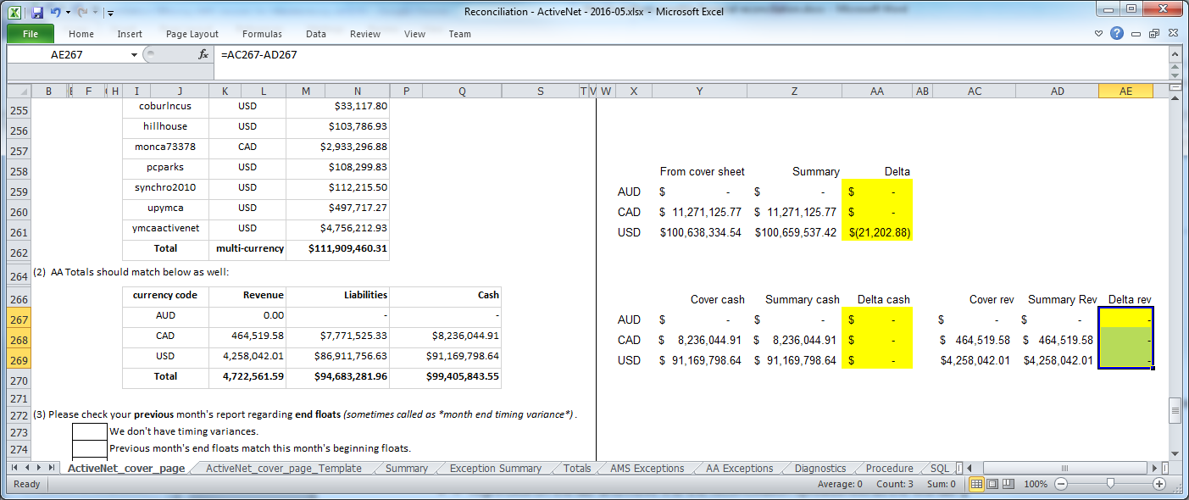

* The formulas compare the cover sheet totals to the corresponding totals on the Summary tab. The Delta regions highlighted should be zero (blank). (In this case, one is non-zero, because I’m waiting for a new cover sheet to match fixes accounting made in the ams_transactions data.)

The cover sheet also has this section:

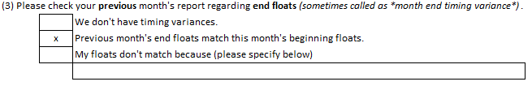

Ideally, we want to be able to check “Previous month's end floats match this month's beginning floats.”, which is almost always the case. To prove this:

* Go to the Exception Summary tab.
* Right-click on the top pivot table, and refresh:

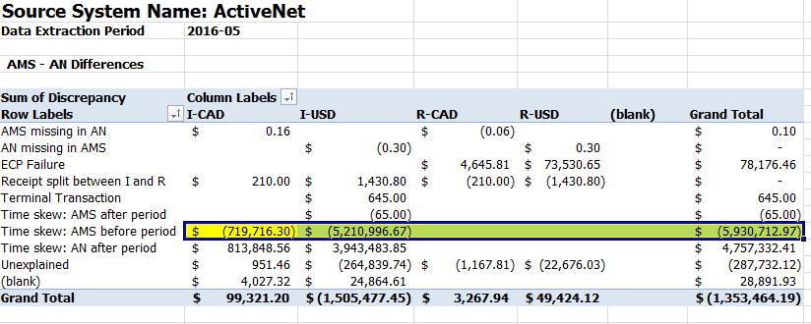

We will compare the highlighted section against the previous month’s spreadsheet.

* Open the previous month’s spreadsheet, and go to the Exception Summary tab:

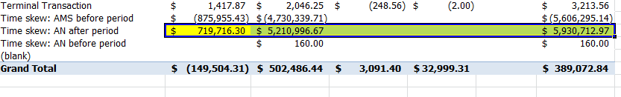

* Confirm that the “Time skew: AMS before period” totals from the current month match the “Time skew” AN after period” totals from the prior month.
* If so, check “Previous month's end floats match this month's beginning floats” on the cover sheet.
* If not, notes on how to research and explain are below.

# Preliminary resolution of AMS data problems

Each AMS exception or AA exception has a type, like “AN missing in AA”. Some exception types represent true financial mismatches between the systems, and are called “defects”. All defects must be explained in the spreadsheet before submitting the reconciliation.

However, before proceeding with the final explanation phase, it’s important to identity and resolve any major data problems. These might involve making requests to other teams to investigate or repair the AMS or AA reconciliation data, or making changes in our procs mapping of AMS accounts to AN orgs. We may need to update some of the source data in the spreadsheet, and we may need to request a new cover sheet, so we want to get any data problems identified as soon as possible.

## Examine AMS exceptions tab for patterns of major new defect counts

Study the AMS exceptions tab defects, and compare to the previous month or months. If the number of defects of certain types is much higher than previous months, or there are a large number of defects for a specific org, or a specific data range, this points to a possible data problem.

The SQL tab of the spreadsheet (which comes from the template) has this SQL you can use to count defects by org to look for problems:

select description, org, count(*)  
from exceptions_ams  
where defect=1  
group by description, org  
order by description, org

In this month, these lines stood out:

Amounts mismatch upymca 4767  
AMS missing in AN AthensPark 57  
AMS missing in AN FauquierCountyP&R 500  
AMS missing in AN MontgomeryCounty 100  
AN missing in AMS Athensparks 57  
AN missing in AMS MecklenburgParks 184

There have been many cases in the past of problems; so the rest of this section has notes on how to repair some of them.

## Use Defects by Org pivot table

On the Exception Summary tab, refresh the “Defects by Org” pivot table. It should show you the number and dollar amount of defects by org, sorted by dollar amount.

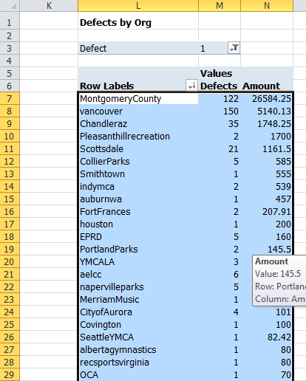

The few orgs at the top will be the ones to investigate. For comparison, you can open the “Defect History” spreadsheet and look at prior months for comparison:

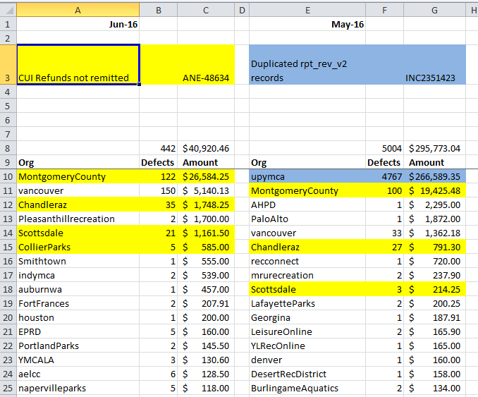

## AMS exception pattern: org name mismatch

When an org is given an AMS account, it would be really nice if it were given a name directly corresponding to the Activenet org name (URL) we use for reconciliation. Alas, that this not the case. For example, in September 2013, an org " Athensparks" first processed transactions. Given the default naming convention, we would have expected the AMS account to be named "Recnet - Athensparks". But it was actually named "Recnet - AthensPark" (singular). As a result

* There are 57 "AMS missing in AN" defects for AthensPark.
* There are 57 "AN missing in AMS" defects for Athensparks.

The amounts on these two groups of defects exactly match. (Or might almost exactly match, if the misnaming was mixed with aa few actual AMs problems).

Usually it’s clear from the name they’re the same org, but not always. The org dbarc has an AMS account “Recnet – MohawkCollege”. If you suspect based on the count that there is a mismatch, you’ll have to research it to be sure.

* Log into the Activenet portal. Lookup dbarc. If the organization name is something like Mohawk, we can be sure.

To fix this, you'll have to add a new line to the proc rec_import_ams_fix and reimport the data:

* In SSMS, modify rec_import_ams_fix.
* Find the following section of code, which consists of a number of calls to override the default org mapping the proc did:

('AlertStation', 'ArtStation'),

('AnchorBaySchool', 'ABSDCommRec'),

('AthensPark', 'Athensparks'),

('Auburnparksandrec', 'Auburnparksandrecreation'),

('BCITRecreationSvcs', 'BCITRecreation'),

* As shown in the sample, add a line to map 'MohawkCollege' to 'dbarc'.
* Recompile the proc.
* Run the proc rec_import_ams_fix (this is called internally by rec_import_ams after the actual import, but since the source AMS data didn’t change, we don’t need to reimport, only to re-fix the receipt numbers, org names, etc.)
* Clear the Yellow selection of the AMS Exceptions tab. Tip to clear range of cells in Excel: Click on the upper-left yellow highlighted cell (C5). Then hit F5 to get the “Go to” prompt. In the reference field of the prompt, type the end of the range you want to clear ((e.g. N150000), then hold down the SHIFT key and click the OK button in the prompt.
* Rerun the proc rec_exceptions_ams
* Paste the results into the AMS Exceptions tab
* Check the Diagnostics tab to make sure we still have $0 deltas.
* Check the AMS Exceptions tab to see if there are any other such examples.

In a month, there may be more than one such org, so it's more efficient to identify them all and fix them in one pass.

## Class orgs

Sometimes a new org shows up in the “AMS missing in AN” category which isn’t an ActiveNet org, but a Class org which was miscoded in the ETL into the ams_transactions table. In this case:

* Querying imported_rpt will show no records for the org.
* Look for the org by name or URL in the US and Canadian portals
* Google for the org name and try to find the online registration website. It will be clear if it’s a AN CUI site. If you can search by “barcode”, it’s a Class site.

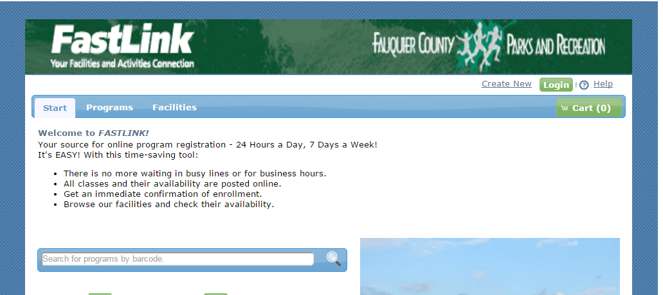

* In this case, what will need to happen is:
  + The ams_transaction data in the Reconciliation database updated (data_set_name changed for these records). Submit SN ticket for Reconciliation ETL, and send email (David Mu / Kenneth So)
  + When they have corrected the data they will send a new cover sheet
  + Then update the spreadsheet contents:
    - Run rec_import_ams: to perform new AMS import
    - Run rec_totals: to get new totals
    - Paste the totals values in the appropriate cells on the “Totals” tab in the spreadsheet
    - Run rec_exceptions_ams: to generate new AMS exceptions
    - Replace exceptions in the yellow highlighted cells on the “AMS Exceptions” tab in the spreadsheet
    - Refresh the formulas on the “Exception Summary” tab in the spreadsheet
    - Check results again on the Diagnostics tab, confirm these records have gone away.
    - Replace the Cover Sheet tab in the spreadsheet with the new one
    - Paste the formulas from the “ActiveNet_cover_page_Template” into the new Cover Sheet tab
    - Confirm the floats again (“AN after period” on previous spreadsheet “Exception Summary” tab vs. “AMS before period” on this spreadsheet) and check the box on the Cover Sheet tab
* To get this process started, write an email like this:

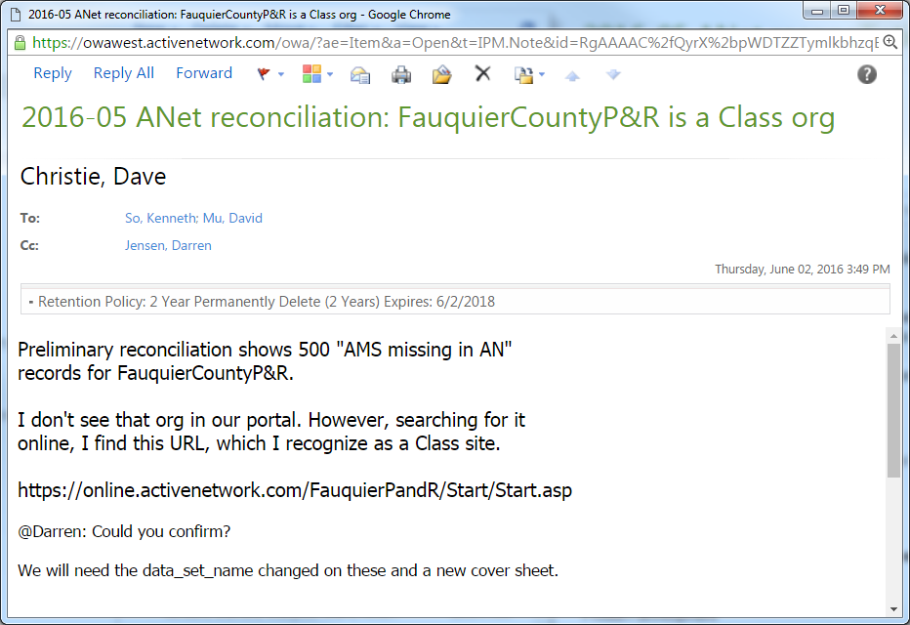

## Mis-coded AMS data

We import our AMS data from the Reconciliation database, ams_transactions table, based on a column data_set_name=’ActiveNet’. Sometimes, this is not properly coded. As a result, we get “AN missing in AMS” defects. For example, in the month 2016-05, there were 184 such defects for MecklenburgParks, all on 5/31, and 6 additional receipts of type “Probable end of month time skew and/or delayed capture”, which were probably actually “AN missing in AMS” defects given this context.

The first step was to be query the source database to find these records. Since we have linked servers, we can do this from the ActiveNet database. On the guess that the entire day was bad, I executed this query:

select rh.receiptheader_id, rh.receiptnumber, rh.datestamp, creditcardamount  
from dbanet10vs.MecklenburgParks.dbo.receiptheaders rh with (nolock)   
where rh.creditcardamount<>0 and rh.datestamp between '2016-05-31' and '2016-6-1'  
order by rh.receiptheader_id

This found exactly the 190 problem receipts. Then I went to ICVerifylog to get the AMS transacton ids:

select ic.refno, rh.receiptheader_id, rh.receiptnumber, rh.datestamp, creditcardamount, ic.*  
from dbanet10vs.MecklenburgParks.dbo.receiptheaders rh with (nolock)  
join dbanet10vs.MecklenburgParks.dbo.icverifylog ic with (nolock)   
 on ic.receiptheader_id=rh.receiptheader_id  
where rh.creditcardamount<>0 and rh.datestamp between '2016-05-31' and '2016-6-1'  
order by rh.receiptheader_id

With these IDs, I could query ams_transactions:

select cct_transaction_id, data_set_name, *   
from reconciliation.dbo.ams_transactions   
where cct_transaction_id in (  
 'pkqA8vlb83795961',  
 'pkqHuz2W68885165',  
 'pkqTygn616370631',  
. . .  
)

This found 190 transactions in ams_transactions, all with data_set_name=null. So I wrote this email to start the datafix process going:

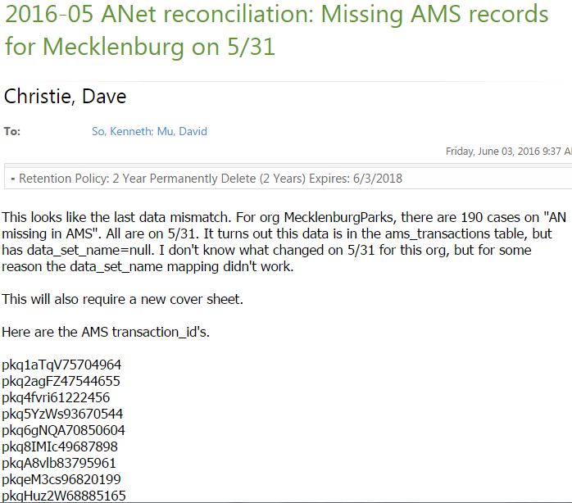

This will require an update to the ams_transactions, and a new cover sheet. However, to move the process along, I hacked the import_ams proc in two places, commenting it with the date, so I would know it was safe to remove later:

-- 2016.6.3: Temporary workaround around ams_transactions data problem   
where (data_set_name='activenet' or ma_name='AN - Mecklenburg')  
-- where data_set_name='activenet'

-- 2016.6.3: Temporary workaround around ams_transactions data problem   
where (ams_void.data_set_name='activenet' or ams_void.ma_name='AN - Mecklenburg')  
-- where ams_void.data_set_name='activenet'

## Apparent ActiveNet bugs

If the analysis indicates a likely problem in ActiveNet, create a Jira ticket for it, which will be used later to explain the defects.

For example, in 2016-5, there were 100 “AMS missing in AN” defects for MontgomeryCounty. There were no other orgs showing large numbers of this defect (the second highest was 7). Moreover, looking at prior spreadsheets, this org had 41 such defects in April, starting on 4/13, and none in the prior months. Also 16.1.1 went live on 4/12. So it sounds like some code change in 16.1.1, combined with some unique configuration in Montgomery, was to blame.

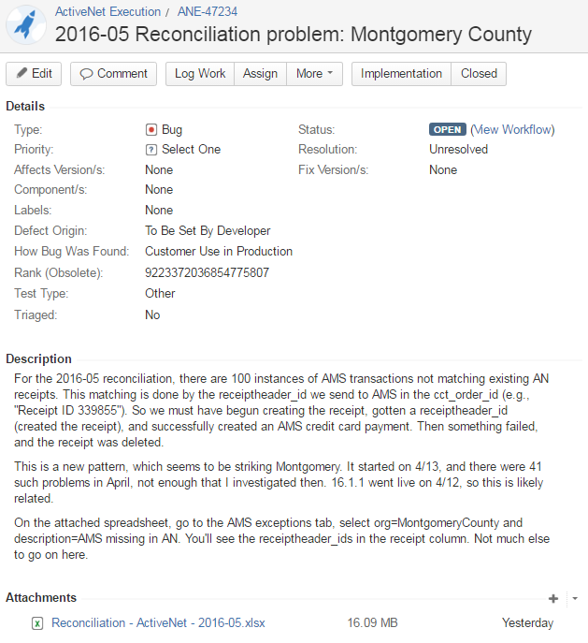

## Float Mismatch

The cover sheet asks us to confirm that the floats match the previous month. For ANet, that means, confirm that the “Time skew: AMS before period” totals from the current month match the “Time skew” AN after period” totals from the prior month. This is generally the case.

If it is not, we need to explain the differences. Here is an example explanation from the 2016-02 reconciliation, which is on the Exception Summary tab.

**Cover sheet explanation:**

|  |  |  |  |
| --- | --- | --- | --- |
| (3) Please check your **previous** month's report regarding **end floats** *(sometimes called as *month end timing variance*)*. This should match this month's **beginning floats**. (Put "x" in the box below, where applies.) | | | |
|  |  |  | We don't have timing variances. |
|  |  | x | Previous month's end floats match this month's beginning floats. |
|  |  |  | My floats don't match because (please specify below) |
|  |  |  | There is a $1461.09 mismatch between the January and February floats. This difference is explained on the Exception Summary tab |

**Detail from the Exception Summary tab:**

|  |  |  |  |  |  |
| --- | --- | --- | --- | --- | --- |
| **AMS - AN Differences** |  |  |  |  |  |
| **Sum of Discrepancy** | **Column Labels** |  |  |  |  |
| **Row Labels** | **I-CAD** | **I-USD** | **R-CAD** | **R-USD** | **Grand Total** |
| AMS missing in AN | 4.57 |  | -4.4 |  | 0.17 |
| AN missing in AMS | -4.4 | -1166.64 | 4.4 | 1107.53 | -59.11 |
| ECP Failure |  |  | 7810.43 | 38086.97 | 45897.4 |
| Receipt split between I and R | -0.4 | -32314.08 | 0.4 | 32314.08 | 0 |
| Terminal Transaction | 1 | 1 | -221 | -1 | -220 |
| Time skew: AMS before period | -955110.33 | -4627507.27 |  |  | -5582617.6 |
| Time skew: AN after period | 940558.79 | 4696946.32 |  |  | 5637505.11 |
| Time skew: AN before period |  | 345 |  |  | 345 |
| Unexplained | 6770.99 | 2014.48 | -135.95 | -1336.75 | 7312.77 |
| **Grand Total** | **-7779.78** | **38318.81** | **7453.88** | **70170.83** | **108163.74** |
|  |  |  |  |  |  |
| **Float mismatch explanation:** | I-CAD | I-USD |  |  |  |
|  |  |  |  |  |  |
| Time skew: AMS before period | -955110.33 | -4627507.27 | February |  |  |
| Time skew: AN after period | $ 955,110.33 | $ 4,626,046.18 | January |  |  |
| Discrepancy | $ - | $ (1,461.09) |  |  |  |
|  |  |  |  |  |  |
| Missing records from SQL | $ - | $ 1,461.09 |  |  |  |
| Unexplained amount | $ - | $ 0.00 |  |  |  |
|  |  |  |  |  |  |
| The cause of this difference is 71 records from SanmarcosTx. The new AMS account for pinpad transactions was given the name SanMarcosRegPP, | | | | | |
| thus associating it with a different org. This problem wasn't caught in the January reconciliation, so instead of appearing as a | | | | | |
| timeskew error, it appeared as an "AMS missing in AN" error. These records are found in the AMS exceptions tab of the 2016-01 recon on rows 794 to 864, | | | | | |
| and total exactly 1461.09 |  |  |  |  |  |

To research these, we can use SQL to compare the data in the exceptions_ams table (current month) with the archived data from the prior month. The SQL tab of the spreadsheet has some handy queries for researching various problems, including this case.

# Preliminary resolution of AA data problems

## Examine AA exceptions tab for patterns of major new defect counts

Study the AA exceptions tab defects, and compare to the previous month or months. But in general, the data flow from rpt_rev_v2 to AA is record-to-record, so there is little to fail. Any significant number of exceptions

The SQL tab of the spreadsheet (which comes from the template) has this SQL you can use to count defects by org to look for problems:

select description, org, count(*)  
from exceptions_aa  
where defect=1  
group by description, org  
order by description, org

# Final explanation phase

At this point, you’ve done the following:

* Imported the data and checked internal consistency with the Diagnostics tab.
* Attached the cover sheet and checked its totals and the float
* Identified any unexpected/new/major groups of defects, and determined their cause, resolving in one of a few ways:
  + Requesting a datafix to ams_transactions, reimporting and getting a new cover sheet (in this case the defects go away).
  + Identifying the defects as a result of a data fix, ideally linking it to a ServiceNow ticket and/or a Jira ticket.
  + Writing a Jira bug ticket about a likely Activenet problem to research.

Now it is necessary to “explain all defects”. Here is some background:

* The exception procs generate lists of all transactions which mismatch between AN and either AMS or AA. The sum of these exceptions should exactly explain the aggregate differences between the two systems for the reconciliation period. The Diagnostics tab allows you to confirm this.
* Not all exceptions represent a true financial mismatch which need to be researched and corrected. Many are known artifacts of the reconciliation process (e.g, Time Skews), or of differences of operation between AMS and AN (e.g., for ECP cancellations).
* Exceptions which do represent a financial problem are called "defects".
* The exception procs generate a column called "Defect", which is 0 or 1. If Defect=1, this exception needs to be explained. These are sorted at the top of the result set.
* On a typical month, there are no AA exceptions, or a handful. The documentation below currently doesn't provide any information about how to AA defects.
* On the AMS Exceptions tab, there is a column called Defect.
* On a typical month, there may be more than 100,000 exceptions, most of which are "Time skew" exceptions, resulting from the difference in time zone between the org and AMS.
* There are a few other types of exceptions which are identified by the proc as not defects, such as AMS terminal transactions.
* On a typical month, there may then be 30 to 300 actual defects at the top of the AMS Exceptions tab to explain.

## AMS defect explanation

All defects must have an explanation entered in Column O and sometimes Column P for additional information. Generally, this is a Jira or ServiceNow ticket # in column O of each row, and a brief description in column Q.

Since there are some recurring patterns, there is a proc to help with this:

* Execute the following proc:

rec_explain_defects

It takes a few minutes to run, and generates a result set with explanations of just the defect exceptions, which you can copy directly into the AMS Exceptions tab:

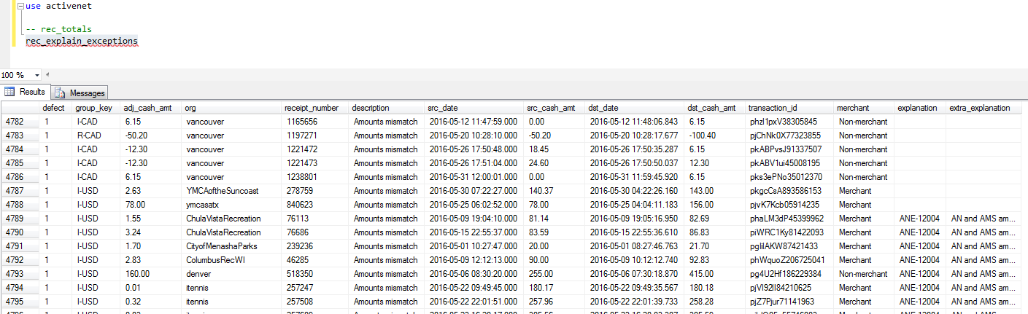

* Select the entire result set and past into the top of the Exceptions tab, at cell C5.
* On the “Exception Summary” tab, refresh the tables
* Check the diagnostics tab to confirm the AMS Remainders are still 0.
* For defects of certain known types, this will have provided the “Explanation” and “Extra Explanation” values.
* The records at the top have a blank explanation, which will have to be individually researched and added.

Now the manual part of explanation:

* For the major exceptions you researched before, enter the Jira or ServiceNow ticket number in column O, and a brief description in column Q.
* In some cases, the rec_explain_exceptions proc may have given the major exceptions a generic explanation. Change it to your custom explanation on these rows.
* Move all the remaining blank rows to the top of the tab, and double-check the Diagnostics tab to make sure you still have Remainders of 0.

Now there is another proc, rec_investigate_receipt, which will help investigate individual receipt mismatches.

* Copy the “Org” and “Receipt columns of the unexplained records:

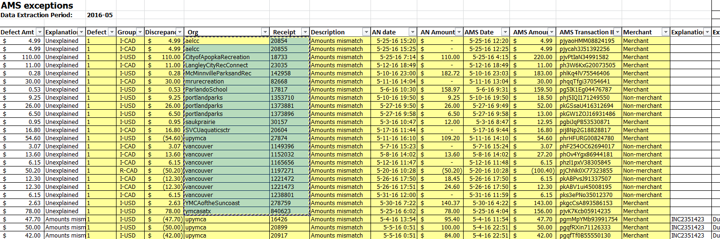

* Paste in into SSMS and convert it to proc calls:\

exec rec_investigate_receipt 'aelcc', 20854  
exec rec_investigate_receipt 'aelcc', 20855  
exec rec_investigate_receipt 'CityofApopkaRecreation', 18733  
. . .

* Execute these rows one or a few at a time. Each proc call will give two result sets: a result set of matching AN records (from imported_rpt table) and a result set of matching AMS records (from imported_ams).

Based on the mismatches, you can find the Jira ticket and description from previous month’s spreadsheets. Refer to the Reconciliation Defects epic for known issues: <https://jirafnd.dev.activenetwork.com/browse/ANE-48983>

Here are some standard cases:

* ANE-42178 AN shows sale & void for $0; AMS shows sale for >$0

Two AN rows, the second being voided, with a cash_amt=0. There is a AMS row, but with entirely different cash_amt:

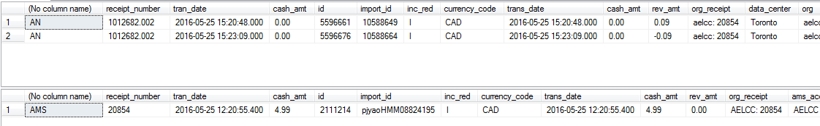

* ANE-20118 AN 1 sale; AMS 2 sales  
  1 AN row, two AMS rows, for same amount

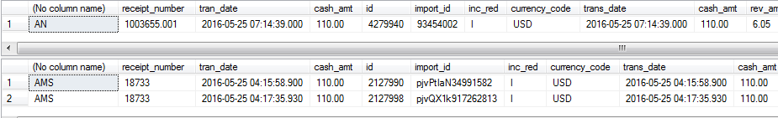

* ANE-8616 Subsystemcode split

Two AN rows and 1 AMS row. The two AN rows are for different subsystemcodes or different sites, and add up to approximately, but not exactly, the AMS total



Now all the exceptions should be explained:

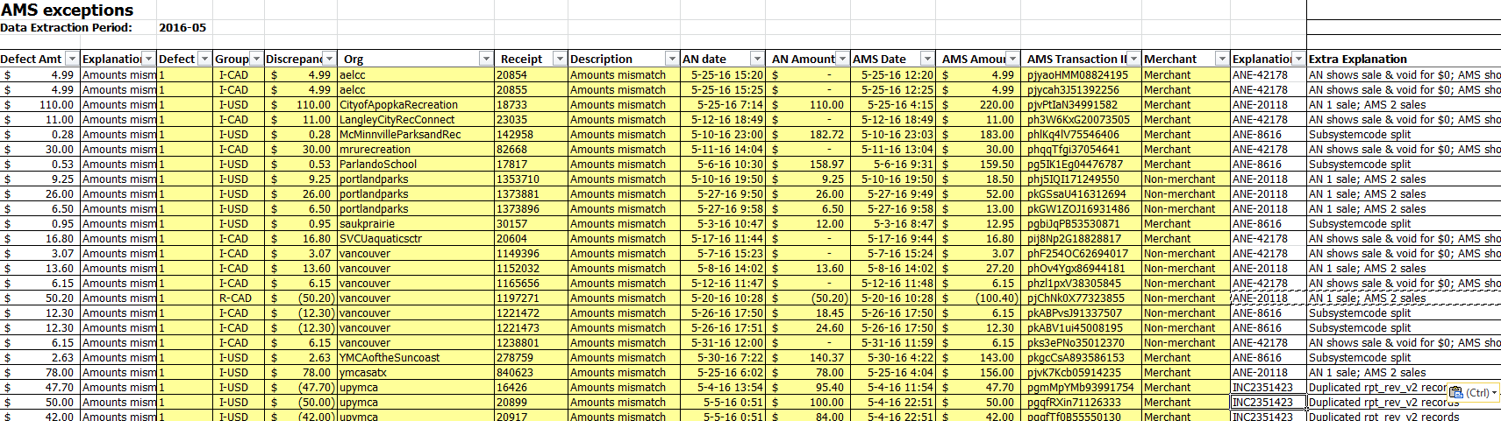

## AA defect explanation

Since the number and dollar value of AA exceptions is generally small, and we’re allowed up to $1000 of unexplained differences, I usually don’t try to explain the few odd defects. It’s time-consuming, requires email contact for each org or defect group with at least Linda Webster and app support, and could only be corrected by a datafix, which we wouldn’t do for a few hours.

Here is an acceptable AA Exception tab.

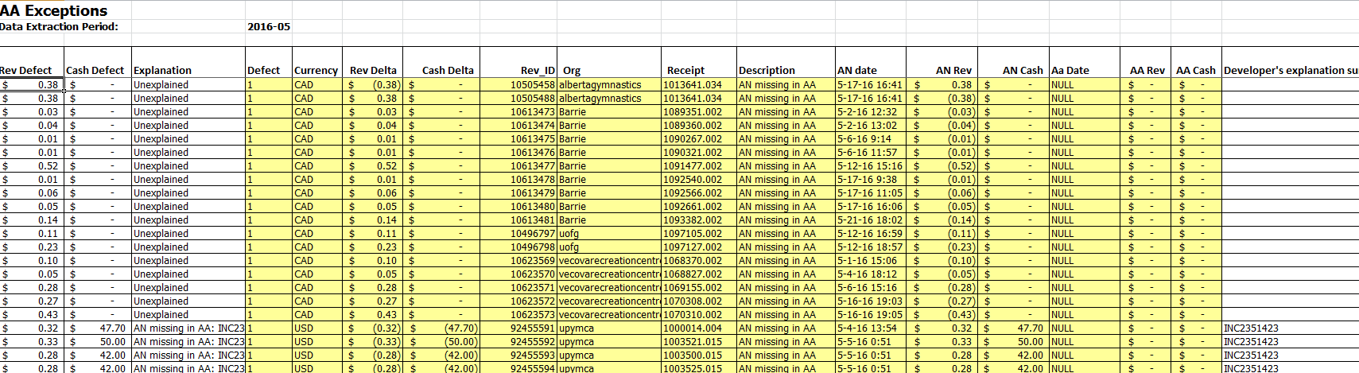

You can look at the Summary tab, and see there is only $2.34 of AA-AN Remaining Exceptions:

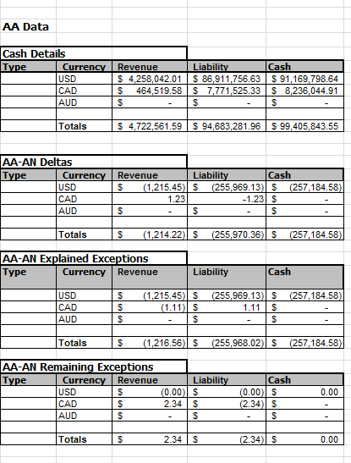

# Final check

Before proceeding with final administrative tasks, re-check the spreadsheet:

* Cover sheet: Verify that the AMS total matches the net of the AMS totals on the Totals tab
* Cover sheet: Verify that the AA total matches the net of the AA totals on the Totals tab
* Cover sheet: Any float changes explained
* Summary tab: Zero dollars of Remaining Exceptions in the “AMS-AN Deltas” table
* Summary tab: Small dollar value of AA-AN Remaining Exceptions
* Exception Summary tab: pivot tables refreshed
* Diagnostics tab: No non-zero remainders

# Final administrative steps

## Generate .zip file of raw transaction data

Every month, in addition to submitting the spreadsheet, you have to submit a raw export of the AN transaction data. Here's how to prepare it.

* In SSMS, execute the following SQL to the get a record count for validation later.

select count(*) from imported_rpt  
where trans_date >=(select value from system_info where keyword='period_beg_date')  
and trans_date<(select value from system_info where keyword='period_end_date')

* In SSMS, right-click on the ActiveNet DB, then select Tasks / Export Data
* In the Export Wizard:
  + Source = SQL Server, server name = WSCASHRECONDB02.active.tan, Database = ActiveNet, SQL Server authentation (** use Windows authentication if that’s how you log in to SSMS)
  + Destination
    - Flat file
    - Output file = Exported_Activenet_YYYY_MM.csv in Reconciliation folder.
    - Delimited
    - Enable “Column names in the first data row”
  + On “Specify Table Copy or Query” form, pick “Write a query to specify the data to transfer”, use this query:

select * from imported_rpt   
where trans_date >=(select value from system_info where keyword='period_beg_date')   
and trans_date<(select value from system_info where keyword='period_end_date')   
order by trans_date

* + All other settings default
  + Finish
  + Confirm that the number of rows exported by the wizard matches the count you obtained in the previous step
* Zip the csv into a file Exported_Activenet_YYYY_MM.zip.

## Backing up procs to the SVN folder

Update SVN with the contents of the current procs, as you will have modified at least the rec_import_ams proc:

* The procs are in SVN at /ActiveNet/Unbranched/Reconciliation/Procs. Find the local folder where you have this checked out.
* Right click on the ActiveNet database in SSMS.
* Click Tasks, then Generate Scripts
* Select specific database objects
* Select Stored Procedures and User-Defined Functions, the Next
* Select file per object
* Directory name = local folder containing the SVN Procs folder above.
* Run the process

## Finish the Cover Sheet

* (4) Assuming you explained all of the AMS and AA exceptions, you can enter 0 for USD and CAD
* (5) Assuming you explained all of the exceptions, enter "No"
* (6) Enter in the three times
  + The first is the time required from start, to having the spreadsheet ready to research exceptions. This should include any trial reconciliation before the 1st. (I use 1hr)
  + The second is the time required to research the exceptions, create Jira tickets, and update the spreadsheet. This is the bulk of the time; I use my recorded time less 2hr.
  + The third is the time to do everything in this "Final processes" section (I use 1hr).

## Update SVN

* Add new files in the following folders to SVN:
* Unbranched\Reconciliation
  + Add the new new .xlsx
  + Add the zip file for the transactional data
* Unbranched\Reconciliation\Procs
  + Add any new procs generated
* Commit the Unbranched\Reconciliation folder with the comment "Reconciliation for YYYY-MM"

## Archiving monthly data

When the reconciliation for a month is complete, the data from all the reconciliation tables must be archived, so the final data can be restored later if needed for an audit:

* Execute the proc rec_archive_period: What it will do is:
  + For  each imported table (the inputs of reconciliation) and each totals_*  and exceptions_* table (the outputs), the proc will copy that table to a  table beginning with "zArchived", then the beginning and end of the  period. The existing tables are unchanged.
  + If changes need to be  made based on accounting input before beginning the next month, the  archive can be re-executed. It will drop the prior archived tables, and  recopy them.

## Submit to Service-Now

Create a service-now ticket

* Categories:
* Service Type: Corporate Applications
* Product / Service Name: Cash Reconciliation Database
* Item Type: Reconciliation
* Issue Type: Monthly Review
* Subject = YYYYMM ActiveNet Reconciliation
* Attach the following files:
  + Reconciliation xlsx
  + Transaction zip file

## Update defect history spreadsheet

* On the reconciliation spreadsheet, copy the Defects by Org pivot table from the Exception Summary tab.
* Open the defect history spreadsheet
* Insert four columns at the left.
* Paste the pivot table under the header (below row 9 in the screen shot below); do a Paste Special / Values.
* Delete everything from your paste except the rows with org data; this includes deleting the grand total row; then move it up to just below the header.
* Copy the header from the previous month and modify it

You should end up with something like this. The highlighted areas show major defects which have been either explained during the reconciliation (the blue area), or been fixed afterwards (the yellow). Do something similar where appropriate, so it’s clear what major historical defects are not known to be resolved.



**Reconciliation Checklist**

|  |  |
| --- | --- |
| **DAY 1** | |
|  | SSMS: Run rec_set_month mm,yy |
|  | SSMS: Run rec_import_rpt |
|  | SSMS: Run rec_import_org_data |
|  | Create spreadsheet by opening "Reconciliation - ActiveNet - Template.xlsx" and saving as "Reconciliation - ActiveNet - YYYY-mm.xlsx" |
|  | On the Totals tab, set the "Data Extraction Period" (yyyy-mm) and "Date Processed" values (mm/dd/yyyy) |
|  |  |
| **DAY 2** | |
|  | SSMS: Run rec_import_ams |
|  | SSMS: Run rec_import_aa |
|  | SSMS: Run rec_totals |
|  | Paste results from rec_totals into the Totals tab |
|  | SSMS: Run rec_exceptions_ams |
|  | Paste results from rec_exceptions_ams to AMS Exceptions tab at cell C5 |
|  | SSMS: Run rec_exceptions_aa |
|  | Paste results from rec_exceptions_aa to AA Exceptions tab at cell d5 |
|  | Check Diagnostics tab, verify that all Delta values are 0 |
|  | Open coversheet spreadsheet from "triad spreadsheet" email and copy the cover sheet to the reconciliation spreadsheet as the first tab |
|  | Copy the blocks of validation formulas from the the "ActiveNet_cover_page_Template" tab into the "ActiveNet Cover Page" tab |
|  | Delete the "ActiveNet_cover_page_Template" tab to avoid confusion |
|  | Verify that all Delta columns in the validation formulas on the cover page are zero (blank). |
|  | On the "Exception Summary" tab, Right-click on the top pivot table, and refresh |
|  | Verify that previous month end float amount matches this month beginning float amount by checking "Exception Summary" tab |
|  | Do preliminary check of exceptions on the "AMS Exceptions" tab to see if there are significant unexplained exceptions. Handle issues as necessary. Refer to the help document above. |
|  | Do preliminary check of exceptions on the "AA Exceptions" tab. Handle issues as necessary. Refer to the help document above. |
|  | SSMS: Run rec_explain_defects |
|  | Paste the results from rec_explain defects to the AMS Exceptions tab at cell C5 |
|  | If there are still any unexplained exceptions on the AMS Exceptions tab, investigate them, creating a Jira ticket if necessary |
|  |  |
| **Final validations** | |
|  | Cover sheet: Verify that the AMS total matches the net of the AMS totals on the Totals tab |
|  | Cover sheet: Verify that the AA total matches the net of the AA totals on the Totals tab |
|  | Cover sheet: Verify that any float changes explained |
|  | Cover sheet: Verify that all Delta columns in the validation formulas are still $0 (blank). |
|  | Summary tab: Zero dollars of Remaining Exceptions in the “AMS-AN Deltas” table |
|  | Summary tab: Small dollar value of AA-AN Remaining Exceptions |
|  | Exception Summary tab: Refresh pivot tables and verify there are $0 in unexplained or blank exceptions |
|  | Diagnostics tab: Verify all remainder amounts are still $0 (blank) |
|  |  |
| **Finish the cover sheet (assumes all verifications pass and all issues have been resolved):** | |
|  | Row (3): Check the box by "Previous month's end floats match this month's beginning floats" |
|  | Row (4): Enter 0 for USD and CAD |
|  | Row (5): Enter "No" |
|  | Row (6): Enter the time values requested |
|  | Row (7): Enter your name |
|  | Row (8): Enter the date you finished the spreadsheet |
|  |  |
| **Finish up:** | |
|  | SSMS: Export ActiveNet DB for backup. Refer to the "Generate .zip file of raw transaction data" section in the help document above. |
|  | Update the "Defect history.xlsx" spreadsheet, adding section for current month exceptions from the "AMS Exceptions" tab |
|  | Zip the export file Exported_Activenet_YYYY_MM.csv to Exported_Activenet_YYYY_MM.zip. Can delete the .csv file when finished. |
|  | Save any stored proc changes. Refer to the "Backing up procs to the SVN folder" section of the help document above. |
|  | Check files into repository: spreadsheet, DB backup zip file, stored procs, and defect history spreadsheet. |
|  | SSMS: Run rec_archive_period to archive the data which may be needed for future audit |
|  | Create a Service Now ticket to submit the Reconciliation spreadsheet and DB backup zip file. Refer to the help document above for details. |